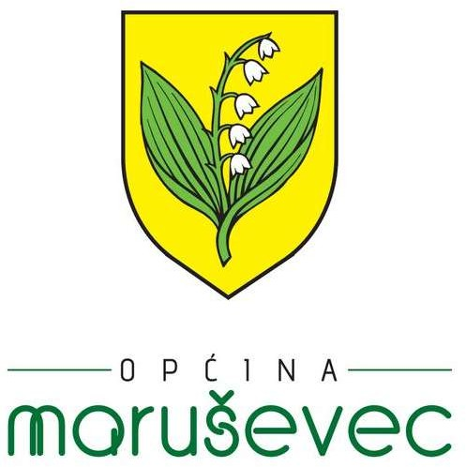MALONOGOMETNA LIGA MARUŠEVEC JESEN - 2024/2025

|  |  |  |  |
| --- | --- | --- | --- |
| **1.** | **01.09.2024.** | |  |
| 10 | BRODAROVEC | KAPLA | 3-5 |
| 10 | CERJE | NEPTUN | 1-6 |
| 10 | GMAJNA | JORGOVANI | 9-1 |
| 10 | RAJSKA | MNK DRUŠKOVEC | 2-12 |
| 10 | ČALINEC | NOVAKI | 3-9 |

|  |  |  |  |
| --- | --- | --- | --- |
| **2.** | **08.09.2024.** | |  |
| 10 | KAPLA | NOVAKI | 1-5 |
| 10 | MNK DRUŠKOVEC | ČALINEC | 5-0 |
| 10 | JORGOVANI | RAJSKA | 3-2 |
| 10 | NEPTUN | GMAJNA | 9-1 |
| 10 | BRODAROVEC | CERJE | 3-11 |

|  |  |  |  |
| --- | --- | --- | --- |
| **3.** | **15.09.2024.** | |  |
| 10 | CERJE | KAPLA |  |
| 10 | GMAJNA | BRODAROVEC |  |
| 10 | RAJSKA | NEPTUN |  |
| 10 | ČALINEC | JORGOVANI |  |
| 10 | NOVAKI | MNK DRUŠKOVEC |  |

|  |  |  |  |
| --- | --- | --- | --- |
| **4.** | **22.09.2024.** | |  |
| 10 | KAPLA | MNK DRUŠKOVEC | 3-7 |
| 10 | JORGOVANI | NOVAKI | 2-10 |
| 10 | NEPTUN | ČALINEC | 17-2 |
| 10 | BRODAROVEC | RAJSKA | 0-8 |
| 10 | CERJE | GMAJNA | 7-1 |

|  |  |  |  |
| --- | --- | --- | --- |
| **5.** | **29.09.2024.** | |  |
| 10 | GMAJNA | KAPLA |  |
| 10 | RAJSKA | CERJE |  |
| 10 | ČALINEC | BRODAROVEC |  |
| 10 | NOVAKI | NEPTUN |  |
| 10 | MNK DRUŠKOVEC | JORGOVANI |  |

|  |  |  |  |
| --- | --- | --- | --- |
| **6.** | **06.10.2024.** | |  |
| 10 | KAPLA | JORGOVANI |  |
| 10 | NEPTUN | MNK DRUŠKOVEC |  |
| 10 | BRODAROVEC | NOVAKI |  |
| 10 | CERJE | ČALINEC |  |
| 10 | GMAJNA | RAJSKA |  |

|  |  |  |  |
| --- | --- | --- | --- |
| **7.** | **13.10.2024.** | |  |
| 10 | RAJSKA | KAPLA |  |
| 10 | ČALINEC | GMAJNA |  |
| 10 | NOVAKI | CERJE |  |
| 10 | MNK DRUŠKOVEC | BRODAROVEC |  |
| 10 | JORGOVANI | NEPTUN |  |

|  |  |  |  |
| --- | --- | --- | --- |
| **8.** | **20.10.2024.** | |  |
| 10 | KAPLA | NEPTUN |  |
| 10 | BRODAROVEC | JORGOVANI |  |
| 10 | CERJE | MNK DRUŠKOVEC |  |
| 10 | GMAJNA | NOVAKI |  |
| 10 | RAJSKA | ČALINEC |  |

|  |  |  |  |
| --- | --- | --- | --- |
| **9.** | **27.10.2024.** | |  |
| 10 | ČALINEC | KAPLA |  |
| 10 | NOVAKI | RAJSKA |  |
| 10 | MNK DRUŠKOVEC | GMAJNA |  |
| 10 | JORGOVANI | CERJE |  |
| 10 | NEPTUN | BRODAROVEC |  |